Project Title

Project Subtitle – Short Description here

# The team

# The Concept

1-2 paragraphs about your project. What problem are you trying to solve, and how are you solving it?

Make sure you answer the following questions:

* Does the project address a clear need, problem, or opportunity and is the solution clearly explained?
* Is the project’s purpose and basic functionality easily understood?

## Target Audience or Market:

Explain who your audience is. Consider targeted platforms, geography, and demographics. If you can estimate the size of your target audience please do so and cite your source for the estimated data.

### Personas

Create one or two personas who represent your likely users.

## Feedback

Pitch your core concept to a few people who would be in your audience or who have expertise in the kind of project you are making. Note here what you learned from them. The more sources of early feedback you include, the better.

# How it works:

Use this section to talk about how you built your product, how have Microsoft technologies made it feasible?

Include an architecture diagram in this section (example given below). If you need Microsoft-icons, you can [download them here](https://docs.microsoft.com/en-us/azure/architecture/resources/diagrams).

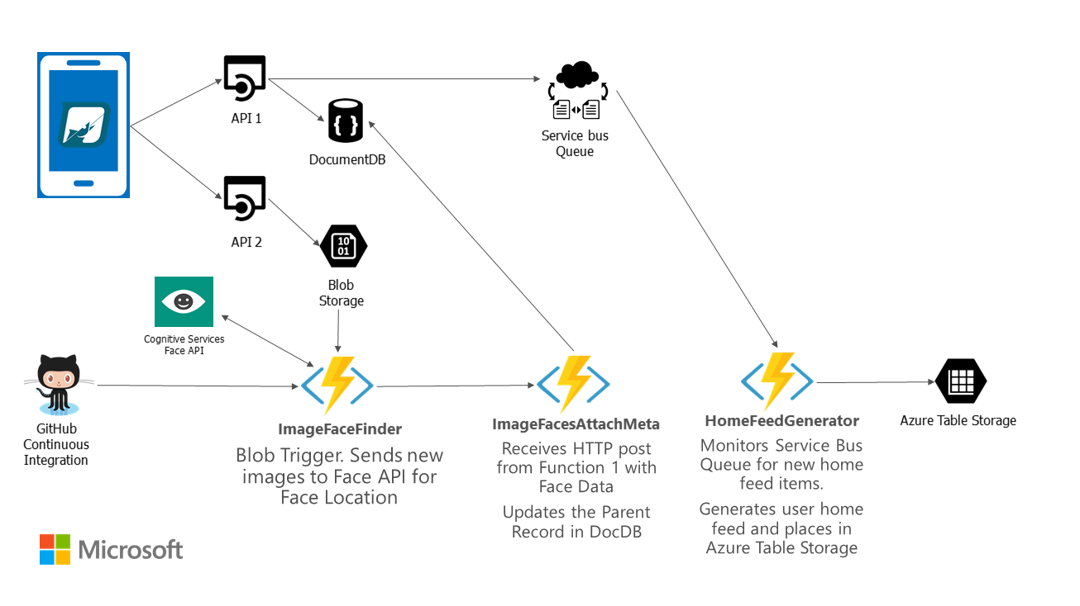

Think about the following questions, when writing this section:

* Does the project make effective and appropriate use of the major features of its chosen platform(s)?
* Were there significant platform features or even platforms the project could have benefitted from but failed to utilize?
* Does the project include innovations in technical design and/or implementation?
* Does the project include innovations in user experience?
* Does the project have a professional degree of production in terms of performance, user interface, visuals, and audio?

## Core Technologies

This includes your key platform(s) as well as specific technologies such as the Kinect SDK, the Unity game engine, or other elements that you believe will be critical to your project’s success.

# The Business Plan:

You don’t need to have a fully fleshed out business plan, we just want to know that you’ve put time into thinking about it.

## Competition:

What products, companies, or services will you directly compete with for your audience? How do you expect to differentiate your project from your competitors?

Think about the following questions in this section:

* Does the project create a new category of product or service?
* Does the project clearly and meaningfully innovate beyond existing products or services?

## Business Model

How will your project make money? If it provides an ongoing service, how will that service be sustainable? If there are critical partnerships you must make for your business model to work, describe those here as well.

Think about the following questions in this section:

* Does the team have a credible plan for getting their project to market in terms of business model, any required partnerships, or other factors?
* Does the project have a reasonable chance of success in its appropriate market given the team’s existing plan?

# Additional Information:

Add any links or information here. Any information you want to share is welcomed!